OS Concept: Network Management

-By Rathod Raja V.

1. Explain OSI reference Layer/Model
Ans:
1. OSI is nothing but the Open System Interconnection Model for network management.
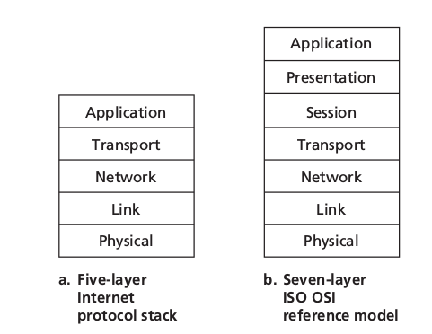
2. It is total 7 layer reference model for how application communicate over a network.

3.

2. What is TCP/IP model of networking and what is UDP/IP model of networking?
Also note the differences between them.
3. How OSI is different from 4 layer TCP/IP model
4. What are different networking protocols?
5. Why do we have MAC and IP addresses?
6. What are different types of topologies viz., bus, ring, star, mesh
7. What is meant by socket?
8. Explain TCP and UDP headers
9. Explain the purpose of CRC/checksum
10. Work on the network commands netstat, net.

